Science
Syllabus 2019-2020
Contact Information
Mrs. Greenwald Room 211 Email: Jgreenwald@wcskids.net phone: 586-574-3175 x.25211

REQUIRED SUPPLIES--PLEASE BRING EVERYDAY!
*Agenda *visible student ID *highlighter * 2 inch binder with lined paper or folder * Science workbook *pencils *checking pens * Spiral Notebook

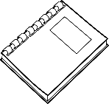
Your Final Grade in Science is Based on Practice Work & Assessments
Assessments: May include, but are not limited to: quizzes, tests, projects, & papers, etc.
80%
20%
Practice Work: A combination of, but not limited to: completing Science Workbook, individual work, group activities, labs, & reviewing learned material.

Classroom Conduct (((behavior) Our classroom will be a safe and productive community for all students to learn. Students must follow these guidelines:
* Be on time, on task and prepared everyday * Be responsible for your own learning
* Respect the teacher, other students, the classroom and yourself * Be positive and KIND at all times
* Participate and help others
Citizenship grades are based on behavior expectations listed above. Failure to follow these guidelines will result in disciplinary action including but not limited to: verbal warning, student/teacher meeting, call home, student behavior plan, detention, a drop in citizenship and/or principal referral.

Grading Scale:: The following WCS
Grade Scale guidelines will be used
In determining student academic
grades. Each card marking period is
individual; no grades will be carried
over from one card marking to another.

______________________________________________________________________________

Letter Grade & Percentage Range

A+ 98 % and above C 76-73
A 97-93 C- 72-70
A-- 92-90 D+ 69-67
B+ 89-87 D 66-63
B 86-83 D - 62-60
B- 82-80 E 59-50
C+ 79-77 F 49-0

See other side...Return this part of the paper to
Mrs. Greenwald by Friday, September 27th.

Technology Cell phones, I-watches, and I-pads can be a distraction to the educational process and are NOT to be in class unless directed by the teacher.
Students are NOT to bring any technology to Science class. If I can see or hear any cell phones I will turn them over to administration. Phones are then held for 24 hours before a Guardian can pick them up from the front office.
Hall passes
Simple…if you do not have your ID and your
Agenda, you WILL NOT be leaving the classroom!
Attendance
Absences: It is important for your child to be in school as much as possible. Children with high absences usually struggle in school. If a science lab is missed due to absence, the science lab will need to be completed on students’ time (lunch or before/after school). This will need to be arranged with me.
Tardies: Tardies are earned when children are not in class with their supplies. BE ON TIME AND READY TO LEARN!

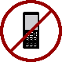

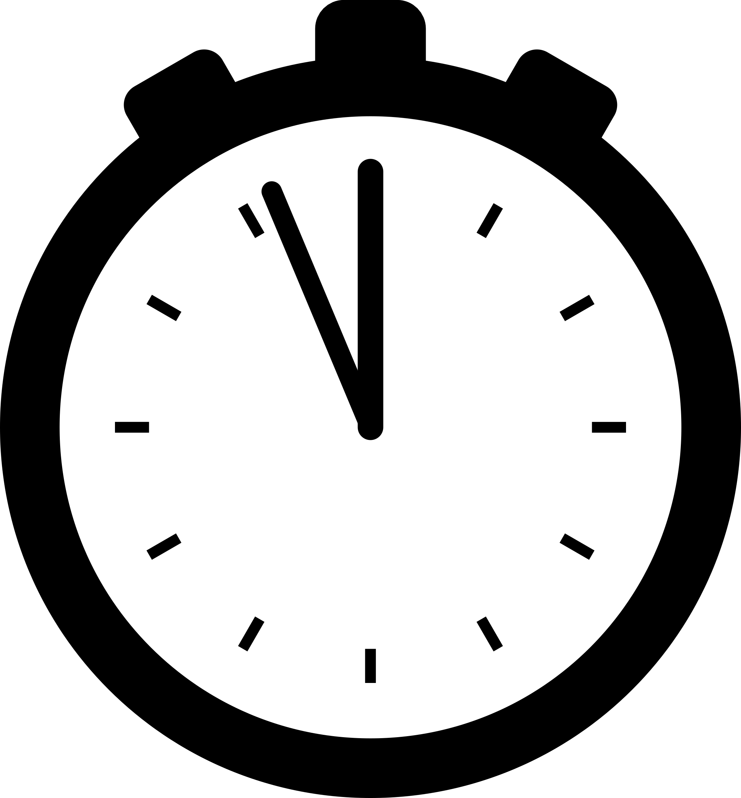
WORK POLICY
I try really hard to give the children enough time to finish class work at school. However, there may be times when work needs to be completed at home. The expectation is that you submit all assignments on time. Late work is accepted on practice assignments however, it must be done completely. Completed late work-worksheet (reason your work is late) is also required in order to receive credit for your late assignment. Late work is due the day before a given quiz or test for the unit.
When you are absent, you are responsible for making up the work. This includes copying any notes. Make up work, including assessments, should be completed within two days of your absence unless you have made other arrangements. If notes are taken, please ask a friend to copy them. If you have any questions regarding the homework or notes, it is your responsibility to ask. Please ask if you are not sure about something that has been covered in class. Assessment retakes given at teacher’s discretion. No extra credit will be offered. Please do your best work when assigned.

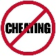
ACADEMIC HONESTY
Be proud of your own work. Don’t try to present someone else’s work as your own. Any form of cheating will NOT be tolerated. The penalty for cheating includes but not limited to: a zero on that particular assessment/assignment no matter what the value, and/or parent/administrator contact.

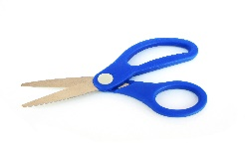
_________________________________________________________________________________________________________________________________________________
Please return this syllabus signed by Friday, September 21, 2019.
I have read the classroom expectations for Mrs. Greenwald’s Science class during the 2019/2020 school year with my parent(s)/guardian. I understand its content and agree to follow the rules and do my personal best.

Print Student Name:______________________________ Student’s Hour______
Student Signature: ________________________________________________
Parent/Guardian Signature: __________________________________________

